CC105 -DATA STRUCTURES AND ALGORITHMS
CC103 – OBJECT ORIENTED PROGRAMMING
Data Structure and Algorithm Implementation
On
Shoe Shop Management System

Presented by:
Alcala, Clar Leynon B. Virgines, Jezer Netho V.

Section
2AG1
Presented to

DR. JENNIFER P. SOLIS
MR. RYAN RAMAGOS

I. Introduction/ Overview of the project
The Shoe Shop Management System is a Java-based desktop application designed to help manage the inventory and sales of a shoe shop. The system provides a graphical user interface (GUI) that allows users to add shoe products, view available inventory, search for specific shoes, sort products according to price, process sales transactions, and display the current stock summary.
The application is developed using Java Swing, which provides the components needed to create an interactive desktop interface. It also uses object-oriented programming concepts, particularly classes and inheritance, to organize shoe product information. The Product class serves as the parent class containing common product attributes, while the Shoe class extends it by adding shoe-specific information such as brand and size.
The system uses an ArrayList as its primary data structure for storing shoe records. This allows the program to maintain a collection of products that can grow as new shoes are added. To demonstrate the application of data structures and algorithms, the system implements Linear Search for finding shoes by name and Bubble Sort for arranging shoes according to price from lowest to highest.
The system also includes a sales module that allows users to select a shoe, specify the quantity to purchase, calculate the total price, and automatically update the remaining inventory. Validation checks are included to prevent invalid numerical inputs and sales quantities that exceed the available stock.
Overall, the Shoe Shop Management System demonstrates how data structures, algorithms, and object-oriented programming can be applied to a practical business scenario. It serves as an educational project that illustrates the basic principles of inventory management and sales processing using Java.

II. Objectives
To develop a functioning Management System that can operate and calculate the items it stores and develop receipts in sales transactions. Utilizing Object-Oriented Programming subjects demonstrating practical applications of data structures and algorithms and simulating managing a shop.

III. Functionalities
The Shoe Shop Management System contains three main interface sections: Dashboard, Inventory, and Sales.
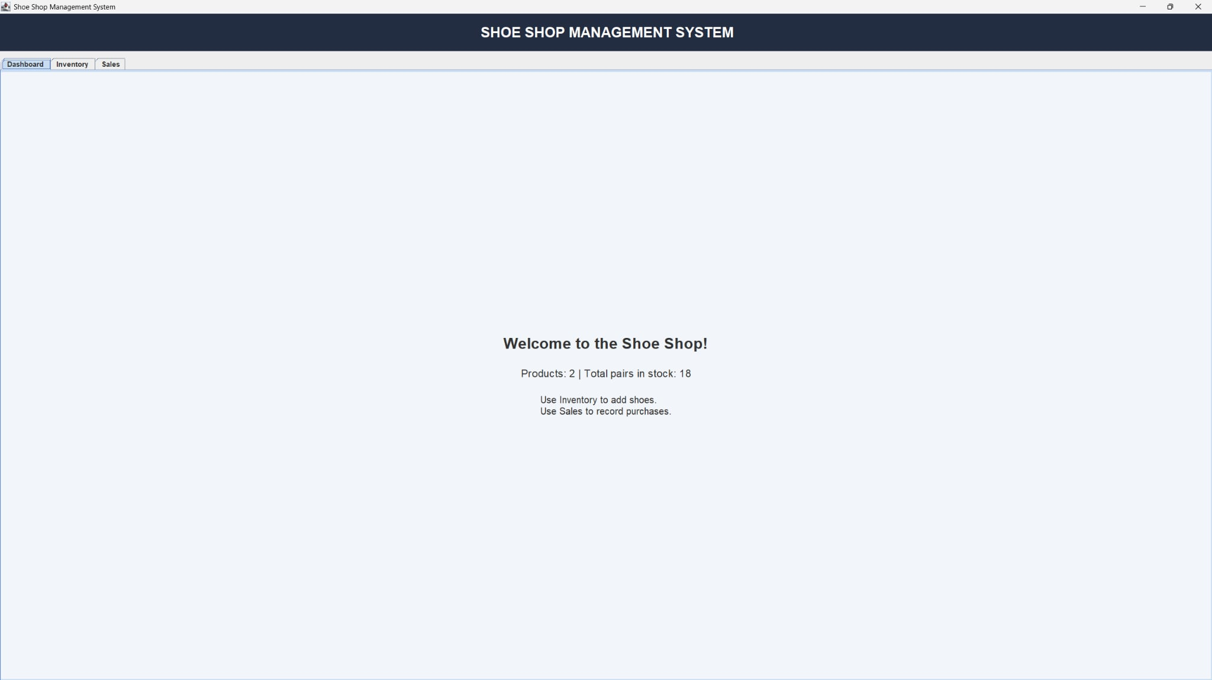
The Dashboard serves as the main overview of the application. It displays a welcome message, the number of shoe products recorded in the system, and the total number of pairs currently in stock.
The dashboard is updated whenever inventory information changes, such as when a shoe is added or a sale is completed.
Functions:
- Display the system welcome message.
- Show the total number of product records.
- Display the total quantity of shoes in stock.

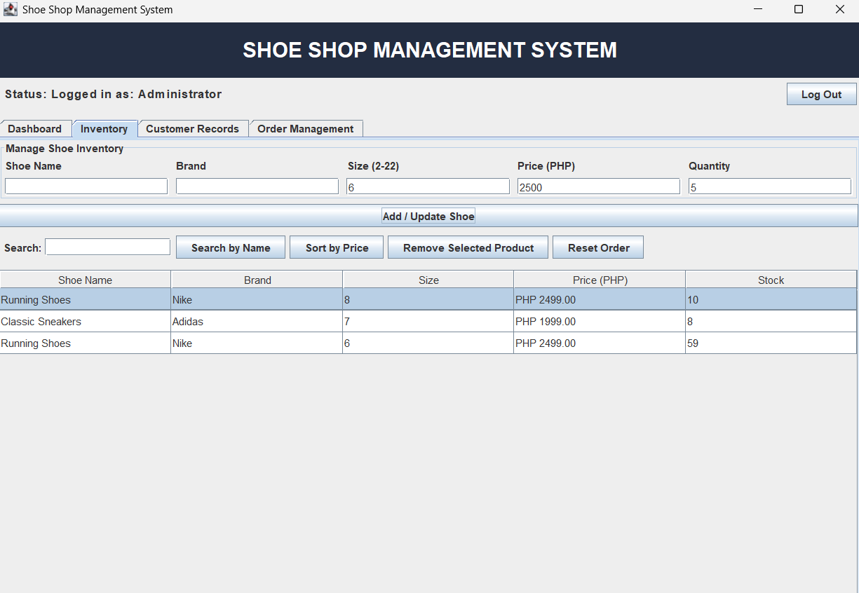

The Inventory section allows the user to add new shoe products and view the existing inventory in a table.
Each shoe record contains the following information:
- Shoe name
- Brand
- Shoe size
- Price in Philippine pesos (PHP)
- Available stock quantity
The system checks the entered information before adding a product. The shoe name and brand must not be empty, shoe size and price must be greater than zero, and quantity must not be negative. Numerical fields must contain valid numeric values.
Main functions:
- Add new shoe products.
- Display inventory records in a table.
- Search for a shoe by name.
- Sort shoe products by price from lowest to highest.
- Refresh the table to display all products in the current inventory order.

The Sales section allows the user to select a shoe from a dropdown list and specify the quantity to purchase.

Before completing the transaction, the system checks whether a shoe has been selected and whether sufficient stock is available. If the requested quantity exceeds the available stock, the sale is rejected and a warning message is displayed.

When the transaction is valid, the system subtracts the purchased quantity from the inventory and calculates the total amount using the formula:

Total Sale = Price per Pair × Quantity Purchased

The system then displays a sales receipt containing the shoe name, brand, size, quantity purchased, price per pair, and total amount.

IV. Data Structures and Algorithms Implementation
a. Data Structures and Algorithms Theory
ArrayList
An ArrayList is a resizable collection in Java that stores elements in an ordered sequence. Unlike a fixed-size array, an ArrayList can automatically grow as new elements are added.

In this project, the system declares the following collection:

private final List<Shoe> shoes = new ArrayList<>();

The collection stores objects of the Shoe class. Each object represents a shoe product with its name, brand, size, price, and stock quantity.

The ArrayList is appropriate for this project because the number of shoe products can change during program execution.

Operations used in the system:

add() – Adds a new shoe record to the collection.
get() – Retrieves a shoe record at a specified index.
set() – Replaces an element at a specified index, which is used when swapping products during sorting.
size() – Returns the number of shoe records.
Iteration – Visits the collection's elements to search, display, sort, or calculate inventory totals.

Object-Oriented Programming and Inheritance
The system uses object-oriented programming to organize product information and behavior.

The Product class is the parent class. It contains three common attributes: name, price, and quantity. It also provides a constructor, getter methods, and a setter for the quantity.

The Shoe class inherits from Product using the extends keyword. It adds two attributes: size and brand.

This relationship avoids repeating common product information in the child class and demonstrates inheritance in Java.

Linear Search Algorithm
Linear Search is a searching algorithm that examines elements one at a time until the target element is found or the collection is exhausted.

In this system, Linear Search locates a shoe by its name. The algorithm starts with the first shoe in the ArrayList and compares each shoe's name with the target name.

The equalsIgnoreCase() method is used to compare names without considering capitalization.

Algorithm steps:

Receive the shoe name entered by the user.
Remove unnecessary leading and trailing spaces.
Check whether the search term is empty.
Traverse the ArrayList from the first shoe to the last.
Compare each shoe's name with the target name.
Return the matching shoe if found.
Return null if no matching shoe exists.
Bubble Sort Algorithm
Bubble Sort is a comparison-based sorting algorithm that repeatedly compares adjacent elements and swaps them if they are in the wrong order.

In this project, the algorithm sorts shoes according to their prices in ascending order. Products with lower prices are moved toward the beginning of the list, while products with higher prices move toward the end.

The implementation includes a Boolean variable named swapped. If a complete pass makes no swaps, the algorithm stops early because the collection is already sorted.

Algorithm steps:

Begin with the first shoe in the collection.
Compare the price of the current shoe with the price of the next shoe.
If the current price is greater, swap the two shoes.
Continue comparing adjacent pairs during the pass.
Repeat the process while the collection is not sorted.
Stop early if no swaps occur during a complete pass.
Refresh the inventory table to display the sorted products.

b. Implementation
The Product class defines the common properties of products managed by the system.
class Product {
protected String name;
protected double price;
protected int quantity;

public Product(String name, double price, int quantity) {
this.name = name;
this.price = price;
this.quantity = quantity;
}

public String getName() { return name; }
public double getPrice() { return price; }
public int getQuantity() { return quantity; }

public void setQuantity(int quantity) {
this.quantity = quantity; }}

The Shoe Class extends the Product and adds shoe-like attributes.
class Shoe extends Product {
private int size;
private String brand;

public Shoe(String name, String brand, int size,
double price, int quantity) {
super(name, price, quantity);
this.brand = brand;
this.size = size;
}

public int getSize() { return size; }
public String getBrand() { return brand; }
}
ArrayList Declaration and Sample Data
The system creates an ArrayList to store the shoe records and initializes it with two sample products.

private final List<Shoe> shoes = new ArrayList<>();

// Sample products
shoes.add(new Shoe(
"Running Shoes", "Nike", 8, 2499.00, 10
));

shoes.add(new Shoe(
"Classic Sneakers", "Adidas", 7, 1999.00, 8
));

Linear Search Implementation
The following method searches the collection for a shoe with a matching name.

private Shoe linearSearch(String searchName) {
String target = searchName.trim();

if (target.isEmpty()) {
return null;
}

for (Shoe shoe : shoes) {
if (shoe.getName().equalsIgnoreCase(target)) {
return shoe;
}
}

return null;
}
Bubble Sort Implementation
The following method sorts the shoe records according to price from lowest to highest.

private void bubbleSort() {
for (int i = 0; i < shoes.size() - 1; i++) {
boolean swapped = false;

for (int j = 0; j < shoes.size() - i - 1; j++) {
if (shoes.get(j).getPrice()
> shoes.get(j + 1).getPrice()) {

Shoe temp = shoes.get(j);
shoes.set(j, shoes.get(j + 1));
shoes.set(j + 1, temp);

swapped = true;
}
}

if (!swapped) {
break;
}
}

refreshInventory();
}

Add Shoe Implementation
The addShoe() method receives product details from the inventory form, validates the input, and adds a new shoe object to the collection.
shoes.add(new Shoe(
name, brand, size, price, quantity));
refreshInventory();

Sales Implementation
The following statements demonstrate the main inventory update performed when a sale is completed.

Shoe shoe = shoes.get(index);
int qty = (Integer) saleQuantitySpinner.getValue();

if (qty > shoe.getQuantity()) {
JOptionPane.showMessageDialog(
this,
"Not enough stock! Available: "
+ shoe.getQuantity()
);
return;
}

shoe.setQuantity(shoe.getQuantity() - qty);

double total = shoe.getPrice() * qty;

refreshInventory();

Inventory Refresh Implementation
The refreshInventory() method keeps the interface synchronized with the current shoe records.
private void refreshInventory() {
if (tableModel != null) {
tableModel.setRowCount(0);

for (Shoe shoe : shoes) {
tableModel.addRow(new Object[] {
shoe.getName(),
shoe.getBrand(),
shoe.getSize(),
String.format(
"PHP %.2f", shoe.getPrice()),
shoe.getQuantity()
}); } }}

Graphical User Interface Implementation
The system uses Java Swing components to provide an interactive desktop interface.

The main components include:

JFrame – The main application window.
JTabbedPane – Organizes the Dashboard, Inventory, and Sales sections into tabs.
JPanel – Groups related interface components.
JTable – Displays shoe inventory records.
JTextField – Accepts shoe details and search terms.
JButton – Executes actions such as adding, searching, sorting, and completing sales.
JComboBox – Allows the user to select a shoe for a sales transaction.
JSpinner – Accepts the quantity to purchase.
JOptionPane – Displays notifications, search results, errors, and sales receipts.
The GUI is initialized through the main() method, which uses SwingUtilities.invokeLater() to create and display the application on the Swing event-dispatch thread.

4.15 Program Execution Flow
The general execution flow of the Shoe Shop Management System is as follows:

The application starts and opens the main window.
Sample shoe records are loaded into the ArrayList.
The dashboard, inventory table, and sales dropdown are initialized.
The user selects an operation from the available tabs.
The system processes the selected operation.
If the operation changes inventory, the collection and relevant interface components are updated.
The application continues running until the user closes the window.

